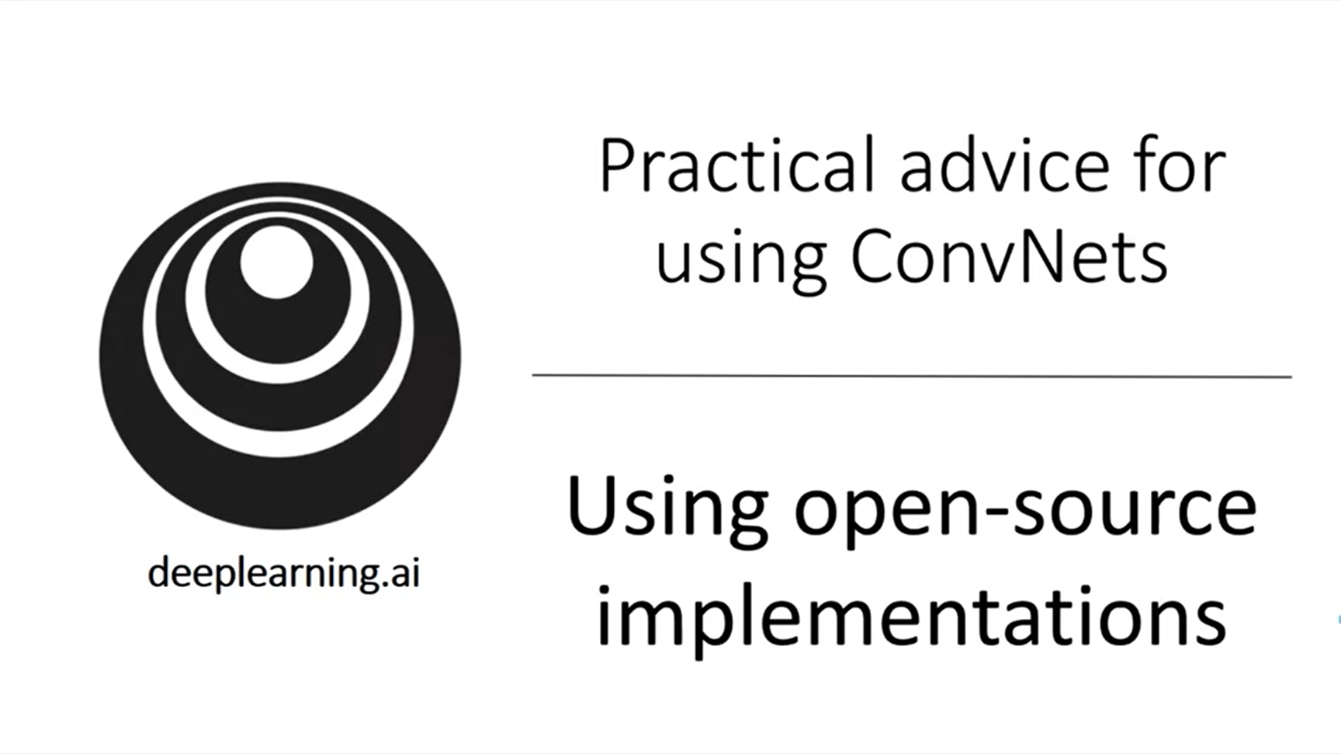

Andrew wants to give some more practical advice on how to use the architectures that we have learned about.

It turns out it is quite difficult to build these architectures from scratch because they include lots of details.

Fortunately, researchers publish their source code on, for example, github. Using the authors’ implementation you can get going much faster.

It is really easy to download source code from github. Let’s look at resnets.

Git clone [REPO_URL]

This particular implementation uses the caffe framework but there are other implementations using other frameworks.

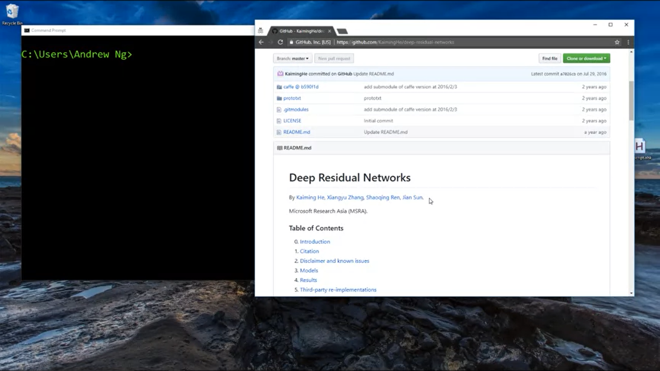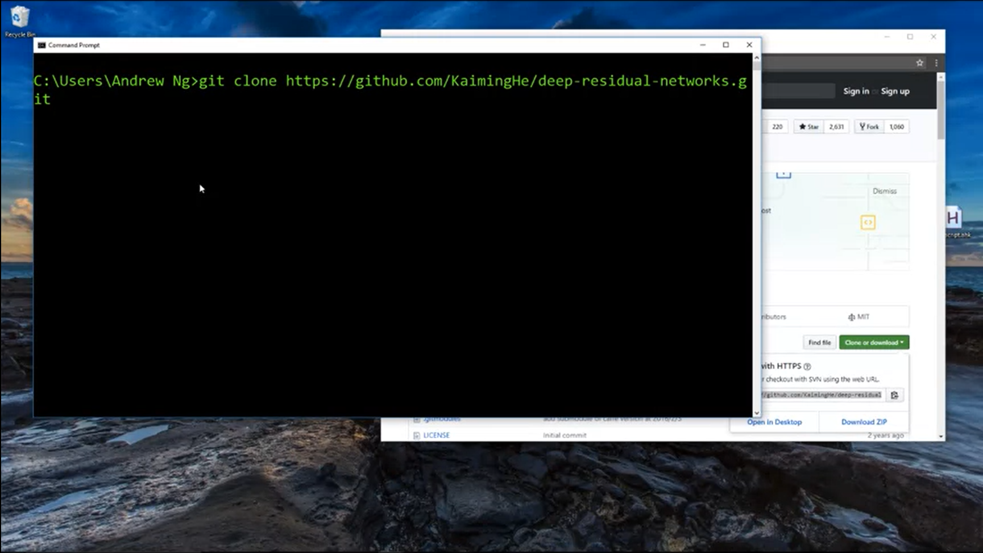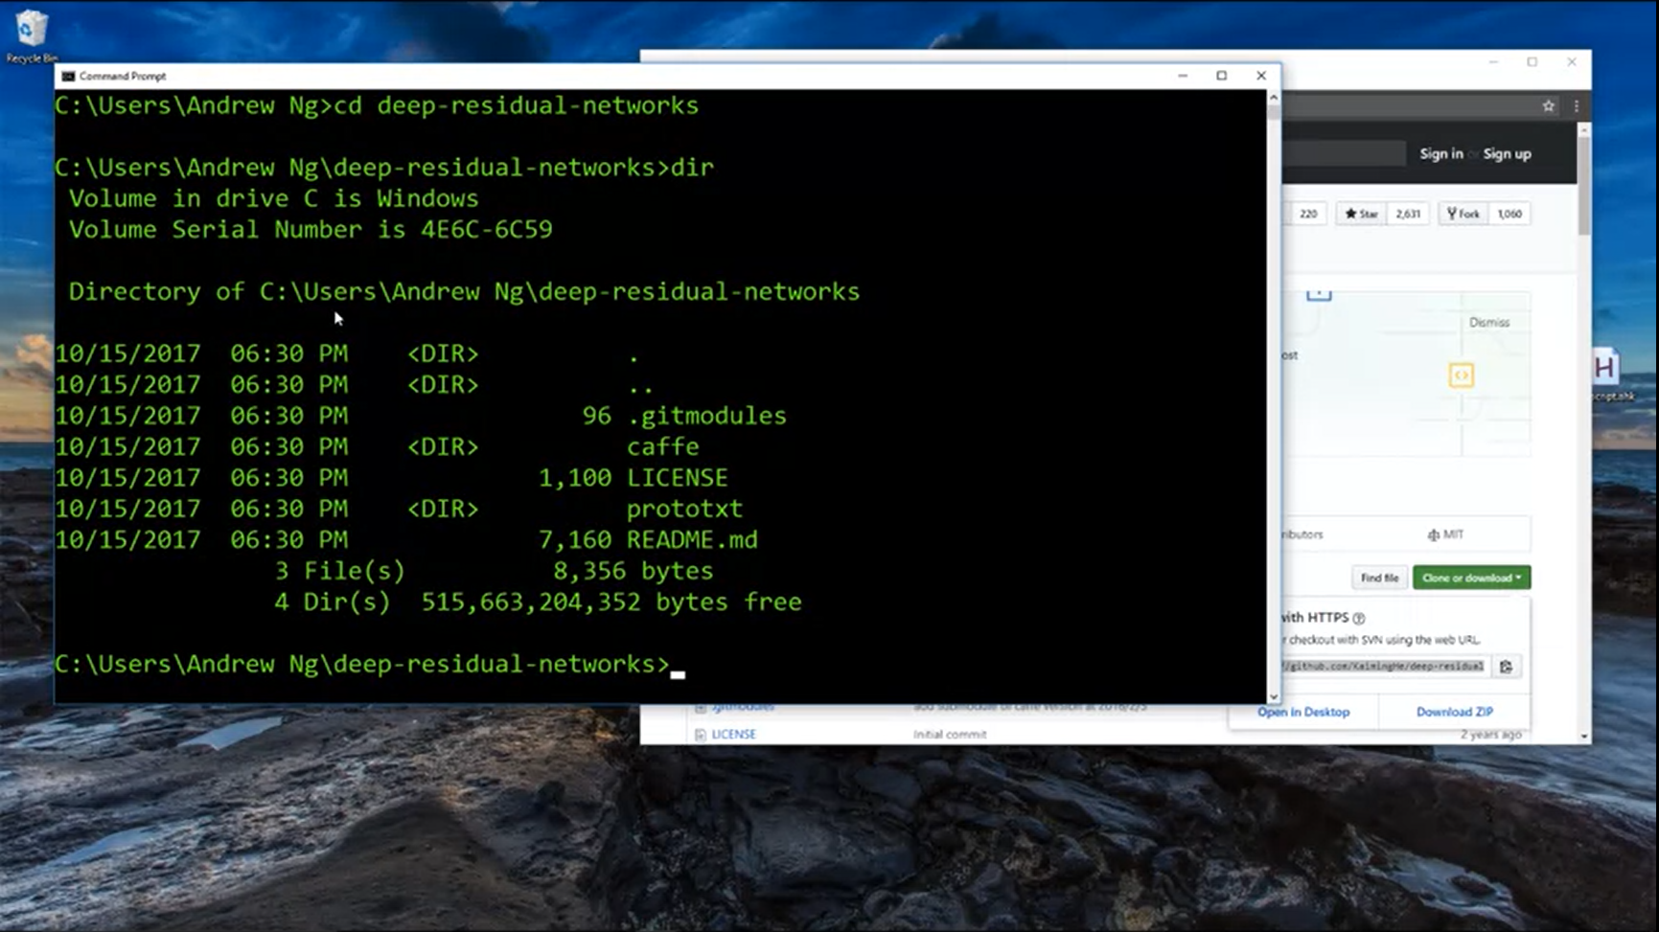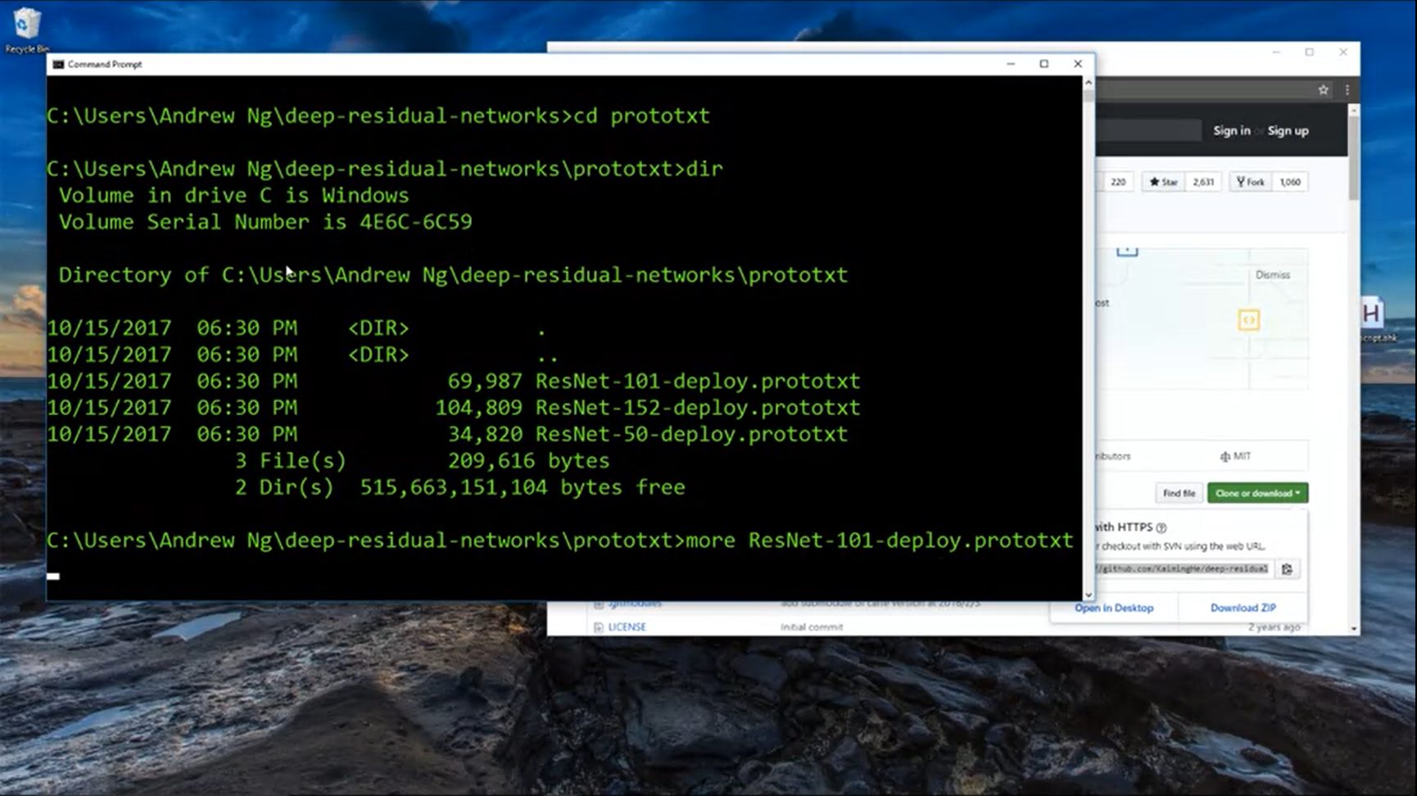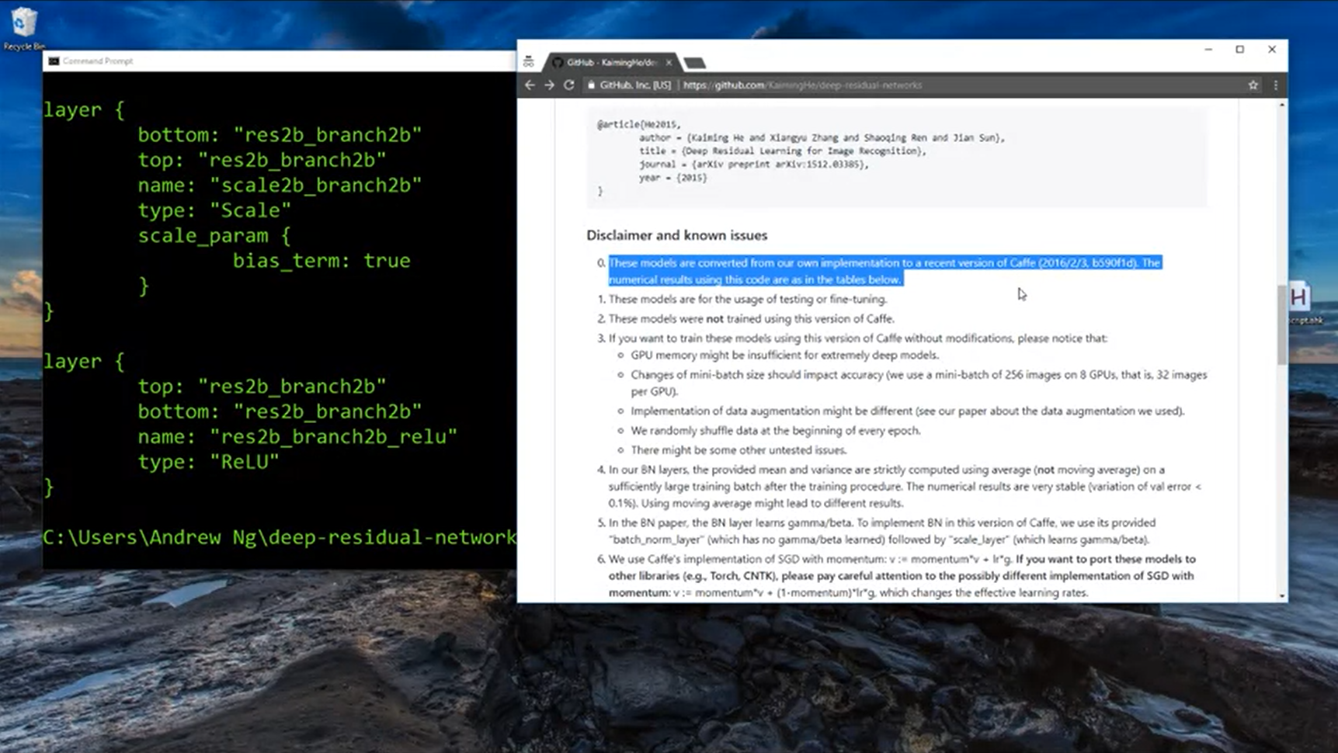

A common workflow to develop a computer vision application is to pick an architecture that you like and look for an open source implementation to start building from there.

An additional advantage is that a lot of these networks take a long time to train. So we can also use transfer learning to start with pretrained weights.

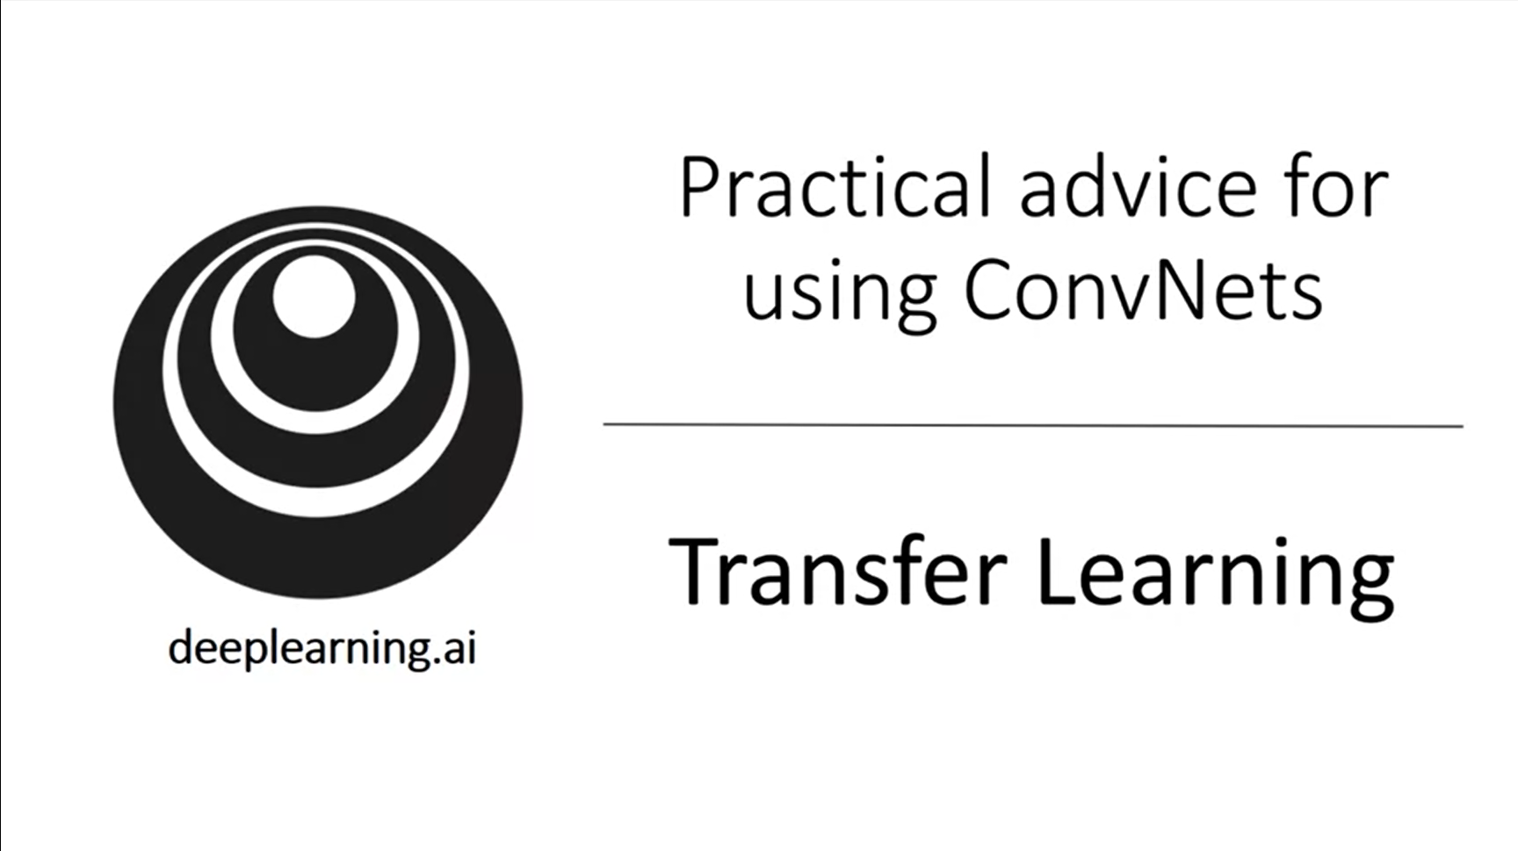

Rather than training weights from scratch (random initialization) you can make much faster progress if you use the weights that someone already trained and use that as pretraining and transfer it to your new task.

There are lots of online datasets for computer vision (image net, ms coco, pascal type of datasets).

Training of convnets can take weeks and many GPUs.

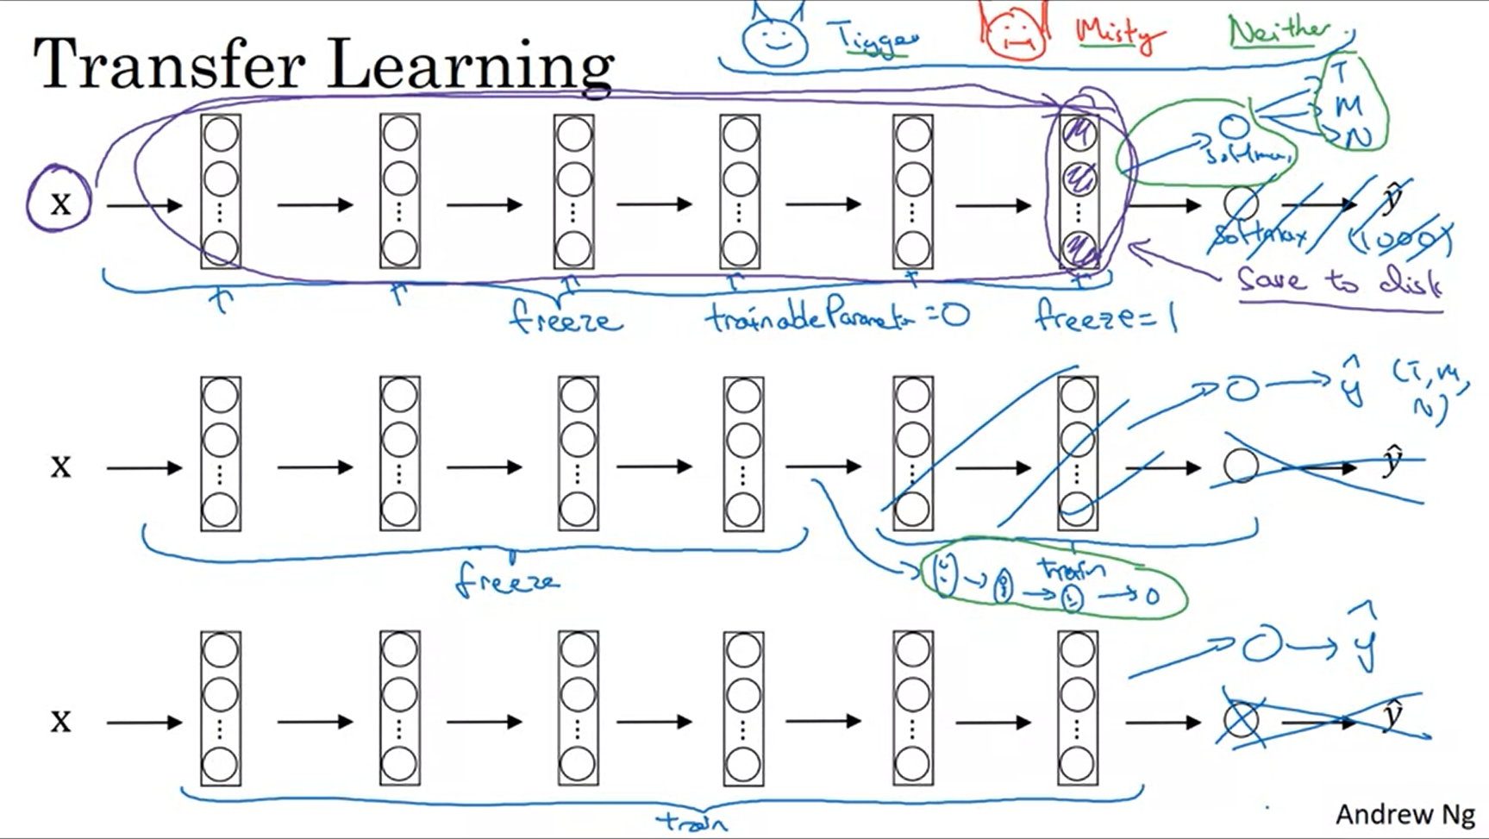

Example: cat detector to detect pet cat.

You do not have many images of your pet cats -> recommendation: use transfer learning.

There are lots of networks that have been trained on the imagenet. Take one of these networks, remove softmax and add your own softmax. Freeze the parameters of all other layers.

This approach allows you to get good performance even with a small dataset.

Transfer learning and weight freezing is supported by deep learning frameworks.

What helps with training is to precompute the activations of the last frozen layer (fixed function) and save the values to disk. Then you train the shallow softmax model based on these saved activations. Like this you do not need to recompute the whole network for every epoch / pass through the training set.

If you, however, have a larger dataset, then you can freeze less layers and train more layers. Or you can even replace the later layers with your own layers.

If you have a lot of data, you can take the open source network as initialization and train the whole network yourself.

The more data you have, the more layers you can train.

In practice, transfer learning is really useful and usually you do better when you use it.

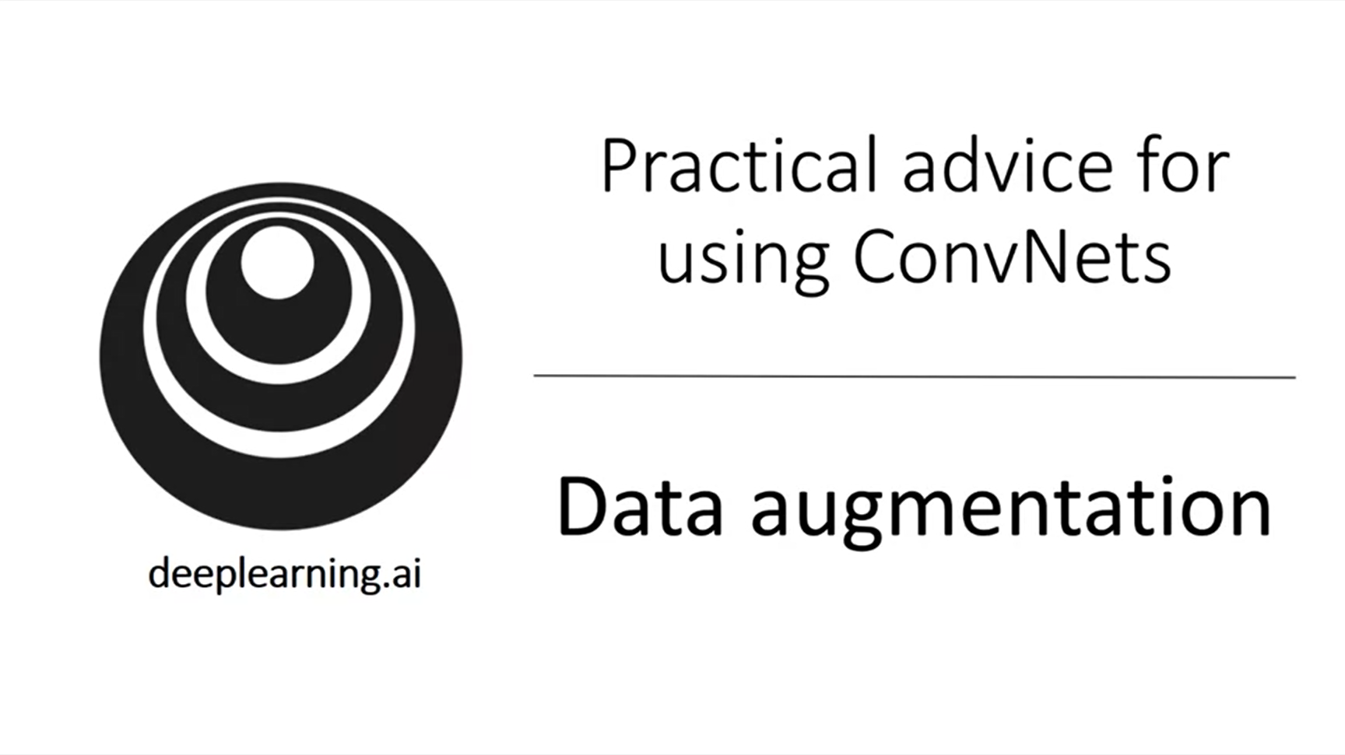

This technique is often used to improve the performance of computer vision applications by getting more data.

In practice for almost all computer vision tasks having more data will help. This is not the case for all domains but for computer vision we always grave for data.

This also helps when using transfer learning.

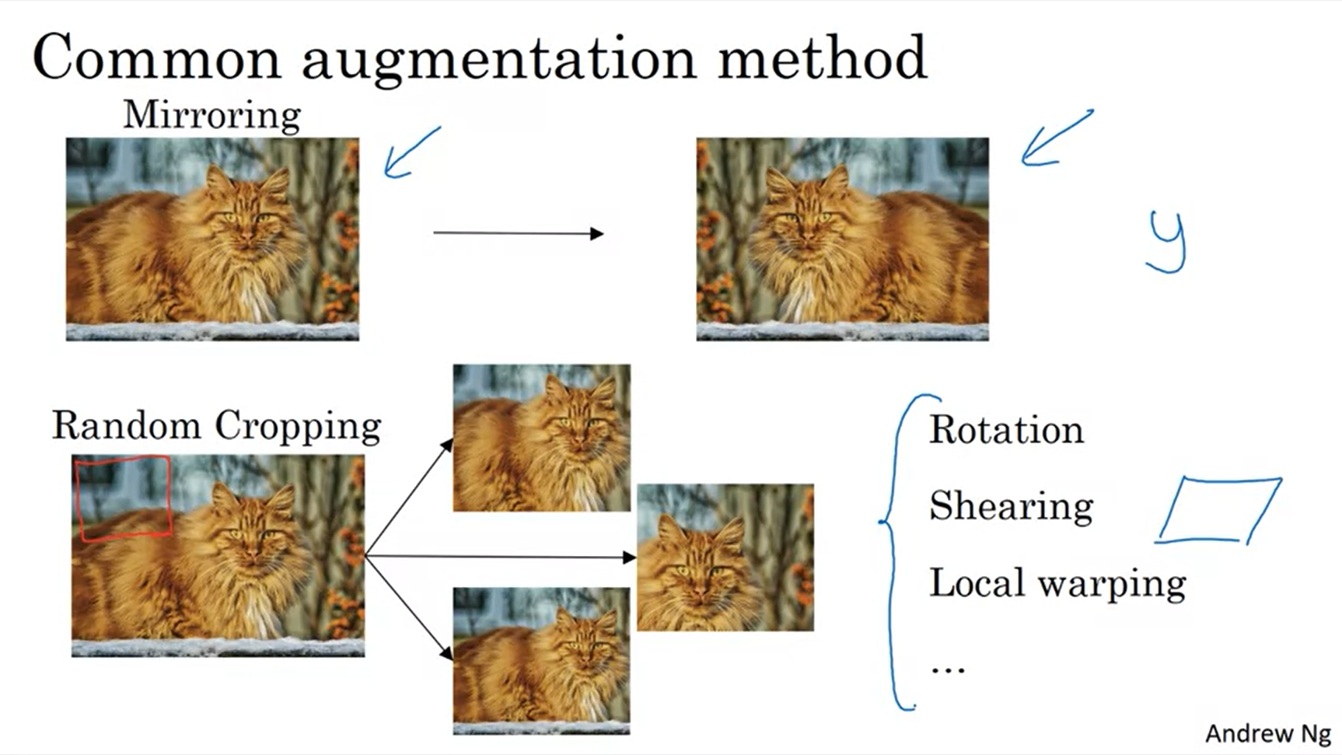

Examples for data augmentation.

Random cropping is not perfect (e.g. red frame) but in practice it works well if the random crop is a reasonably large subset of the entire image.

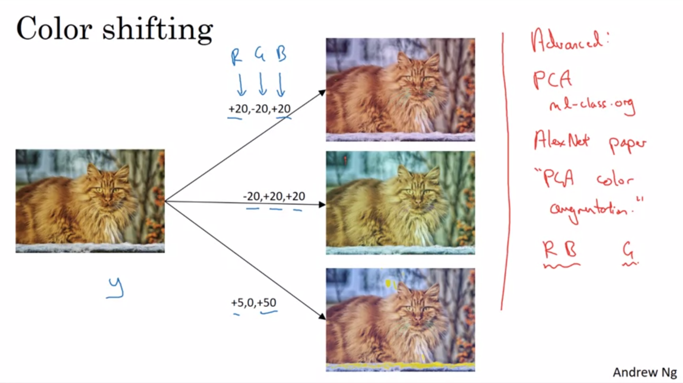

For illustration purposes these are dramatic changes. In practice you would take smaller values from some probability distribution. The intuition is that if the light was a bit different, the label of the image would still be the same. This makes the learning algorithm more robust to changes in colors in the images.

PCA color augmentation: if the image is mainly purple and not green, the algorithm will add relatively a lot to the red and blue channel but not to green (it keeps the overall color tint the same).

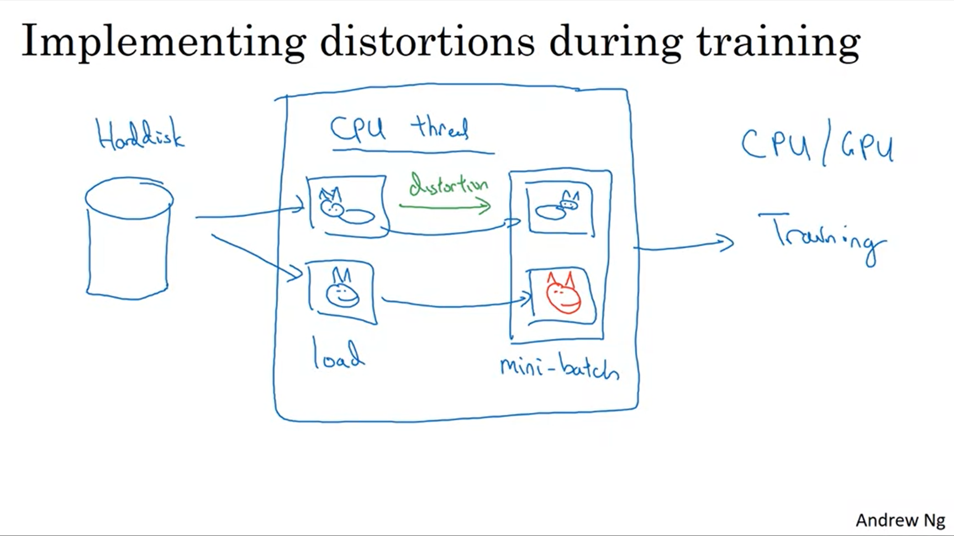

Stream of images from harddisk. Use one CPU threat to compute image distortions (mirroring, color shifting) and create a mini-batch of data like this. The augmented data can then be trained using another CPU threat or even GPU. This can run in parallel.

The data augmentation process also has hyperparameters. Similar to other areas of computer vision a good place to get started would be to look at someone else’s implementation.

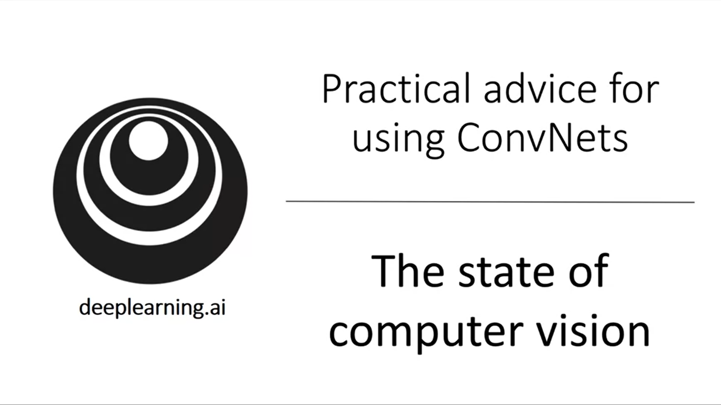

There are a few things that are unique for deep learning applied to the specific field of computer vision.

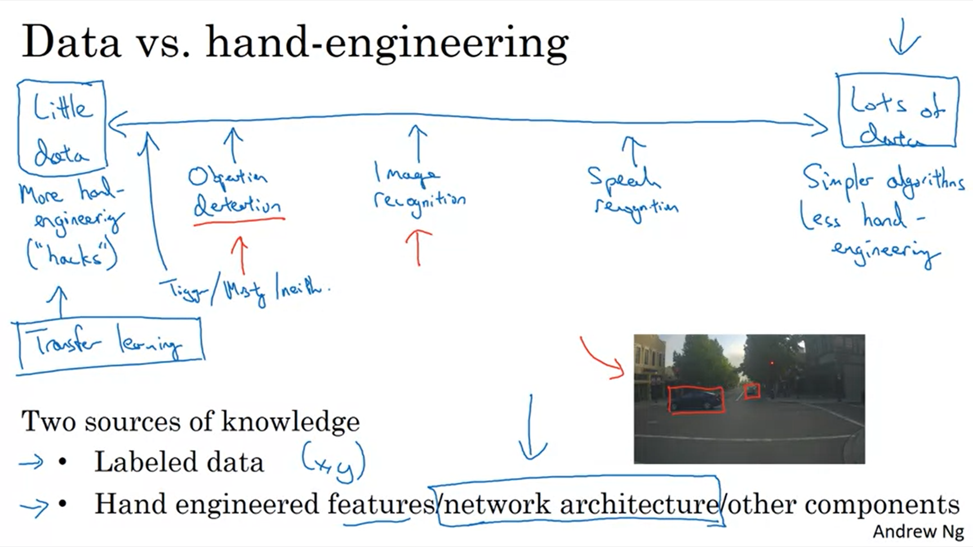

The spectrum of ML applications goes from little data to lots of data. The image datasets are really big but because computer vision is a complex task it still feels like we wish we had more data.

Object detection is more expensive to label so we tend to have less data than for image recognition.

If you have lots of data there is less requirement to hand-engineer features.

Learning algorithms have two sources of knowledge.

Computer vision is trying to learn a really complex function and often we do not have enough data. So historically it has relied a lot on hand-engineering. This is also why there are quite complex network architectures in computer vision.

In the last couple of years the data has increased significantly for computer vision.

Transfer learning helps a lot when you have little data.

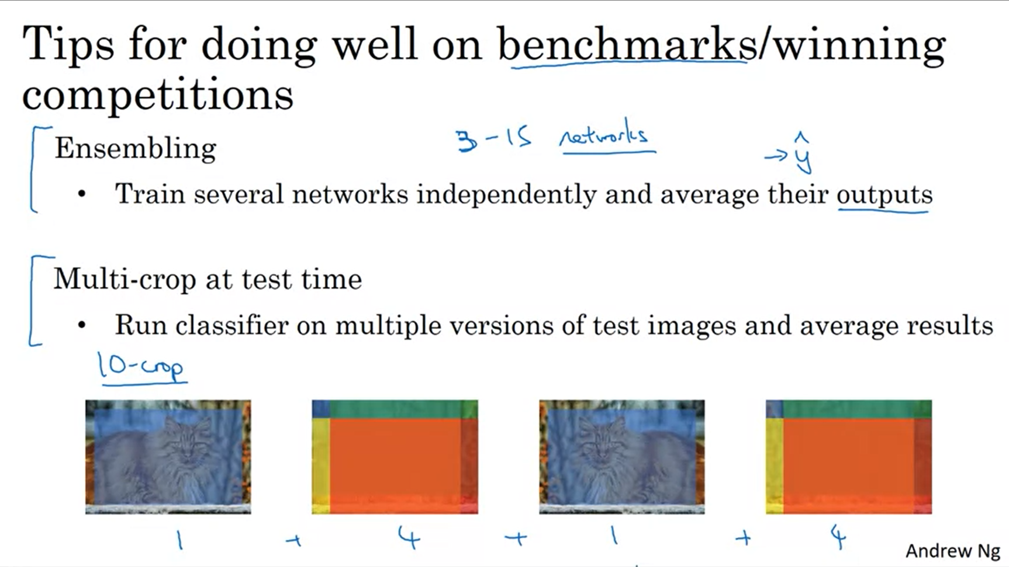

There is a lot of attention on doing well on benchmarks in computer vision. Some research includes techniques that you would not deploy to production applications.

Andrew never uses these techniques mentioned above for production applications. They will improve the results slightly.

Using 3-15 networks slows down running time immensely and is expensive.

You can only use these techniques if you have the computational budget.

Keeping all the networks around for ensembling takes up a lot of memory.

Multi-crop also slows down runtime.

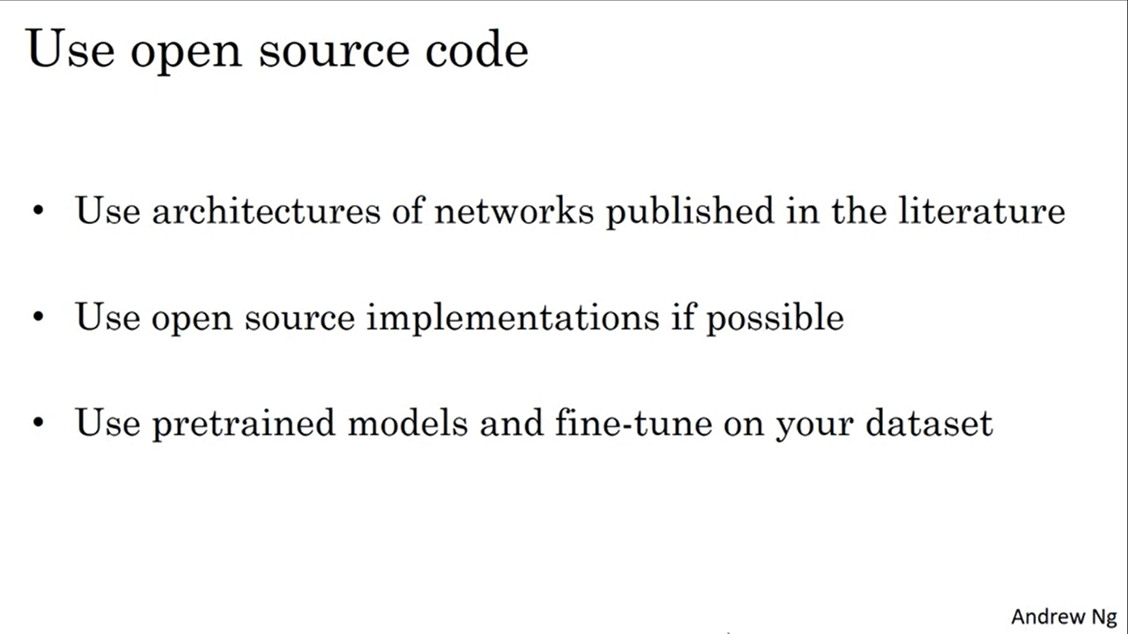

If you want to invent your own computer vision algorithm you might have to start from scratch.